CS 305 Module Two Coding Assignment Template

Instructions
Replace the bracketed text with the relevant information in your own words. If you choose to include images or supporting materials, make certain to insert them in all the relevant locations in the document.

Run Dependency Check

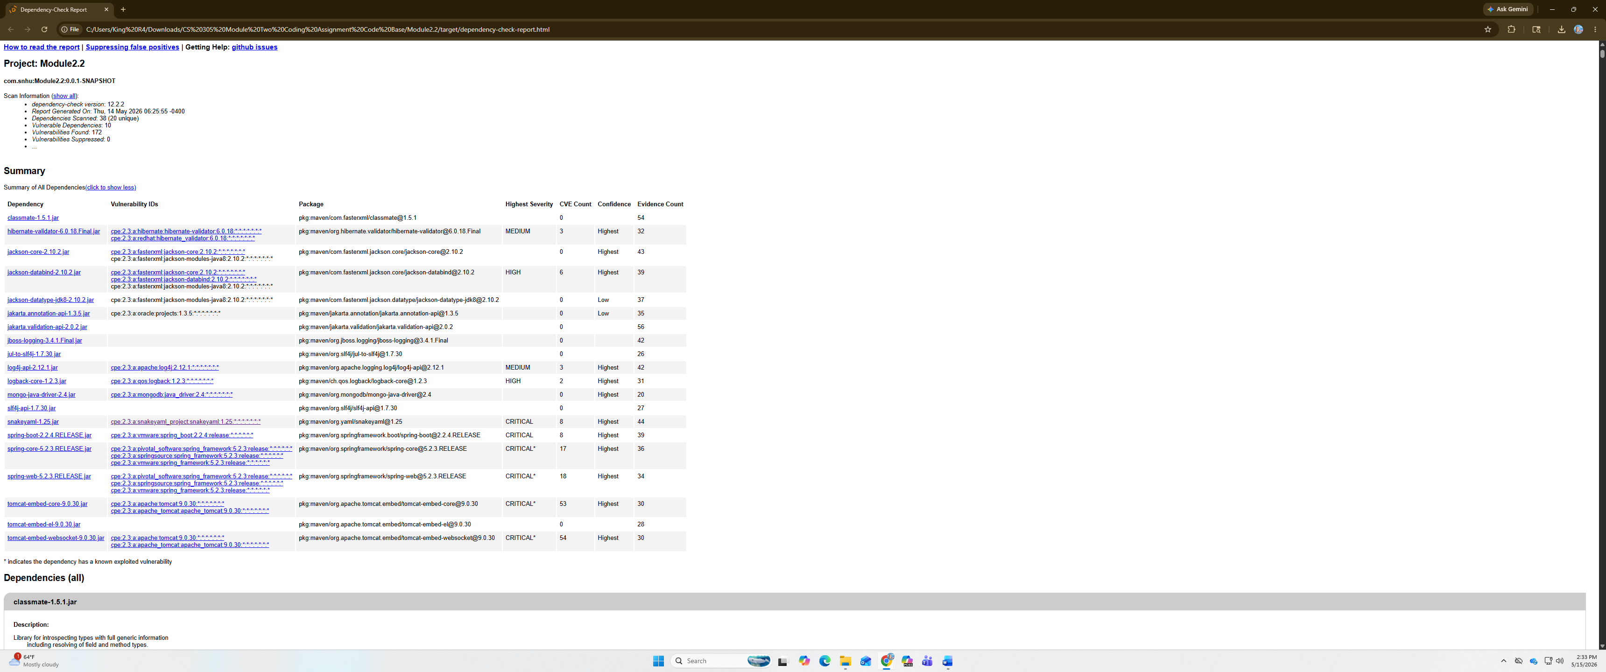

Document Results

Dependency Code | Description
classmate-1.5.1.jar | Library for introspecting types with full generic information including resolving of field and method types.
hibernate-validator-6.0.18.Final.jar | Hibernate's Bean Validation (JSR-380) reference implementation
jackson-core-2.10.2.jar | Core Jackson processing abstractions (aka Streaming API), implementation for JSON
jackson-databind-2.10.2.jar | General data-binding functionality for Jackson: works on core streaming API
jackson-datatype-jdk8-2.10.2.jar | Add-on module for Jackson (http://jackson.codehaus.org) to support  JDK 8 data types.
jakarta.annotation-api-1.3.5.jar | Jakarta Annotations API
jakarta.validation-api-2.0.2.jar | Jakarta Bean Validation API
jboss-logging-3.4.1.Final.jar | The JBoss Logging Framework
jul-to-slf4j-1.7.30.jar | JUL to SLF4J bridge
log4j-api-2.12.1.jar | The Apache Log4j API
logback-core-1.2.3.jar | logback-core module
mongo-java-driver-2.4.jar | Java Driver for MongoDB
slf4j-api-1.7.30.jar | The slf4j API
snakeyaml-1.25.jar | YAML 1.1 parser and emitter for Java
spring-boot-2.2.4.RELEASE.jar | Spring Boot
spring-core-5.2.3.RELEASE.jar | Spring Core
spring-web-5.2.3.RELEASE.jar | Spring Web
tomcat-embed-core-9.0.30.jar | Core Tomcat implementation
tomcat-embed-el-9.0.30.jar | Core Tomcat implementation
tomcat-embed-websocket-9.0.30.jar | Core Tomcat implementation

Analyze Results

The severities of the dependencies range from being medium to critical. The dependencies listed can potentially be exploited if not addressed. Critical vulnerabilities should have priority for being resolved first. Some of the dependencies vulnerabilities share that they are susceptible to denial-of-service attacks. Such as snakeyaml is vulnerable to a Denial-of-Service attack if parser I running on user supplied unit, which may cause parser to crash by stack overflow. Another is Spring core 5.2.3 applications are vulnerable to Denial-of-Service attacks when resolving static resources. Overall, the critical vulnerabilities are in snakeyaml, spring-boot, spring-care, spring-core, tomcat core, tomcat el, and tomcat websocket. Once again these should be addressed first and then high severity. Finally, medium can be left last but should still be properly addressed when the time comes.

Filtering out false positives from the dependency-check tool verifies the threat is real, and not a nonexistent one. The threat can be sharing the same name as a piece of software, so filtering false positives makes it so you understand what the threat is. The medium and high vulnerabilities could potentially be false positives. Manually inspecting the code and suppressing non applicable threats allows for a more streamlined dependency check. Updating all high-risk dependencies and performing regular audits allows for the detection of new potential threats or a more identifiable report. Using outdated versions allows exposure to known vulnerabilities, newer versions probably fixed the issue.

